Estates Management, CCLT, Affordable Housing Team 14.12.22

Attending, Sarah Roberts (CC), Matt Hawcroft, Nicola Williams, Andrew George, Stephen Morgan.

Great to meet you all this morning, these are some key notes, outcomes and actions I made, please let me know if they need to be amended etc, apologies in advance if I haven’t recorded some other key points etc.  Can one of you please send onto Matt please and note that I didn’t write his surname down so that needs adding.

1.      Matt Hawcroft was introduced to us as a local resident offering to assist and support the scheme.

2.      SR updated progress with the CC Feasibility Study Funding Scheme – Awaiting sign off before full application process can be published – anticipated mid January earliest, but process to go through.

3.      In meantime, SR advised to prepare cost plan for the project to be worked up in terms of surveys and feasibility (highways, geotechnical, ecology, option agreement/legal costs etc) and what value for money tests have been carried out (e.g. three quotes or one provider due to previously tested VFM exercise/long term relationship/expertise etc) to get ahead of the application process as that will be a requirement.  CLT offered to support Nicola on that.

4.      Pre app will inform full extent of surveys and advice required to support application to finalise budget.  SR confirmed that Max funding available from CC = £40k per project to take to Planning stage.  Upper limit of budget to get to planning stage can be circa £120k but base budget could be circa £70k).

5.      Other Funding - PC to consider budget request to also support with funding – Nicola to ask in Jan PC meeting.  CLT confirmed that they could support/introduce other funding sources.    Soft loan agreements available from venture trusts *(Name….?)* whereby loan only needs to be paid back if scheme is successful and progresses but they require an option agreement to be secured and a positive pre app to offer loan.  Therefore, basic feasibility may be required to inform pre app as initial step.

6.      NDP adopted and red line around farm buildings but not former silage clamp as below.  Live work units supporting policy within red edging and exception sites outside.  SM & SR to review policy @ [https://stendellionpc.com/wp-content/uploads/2019/04/NDP-Reg-14-version-2.pdf](https://eur03.safelinks.protection.outlook.com/?url=https%3A%2F%2Fstendellionpc.com%2Fwp-content%2Fuploads%2F2019%2F04%2FNDP-Reg-14-version-2.pdf&data=05%7C01%7CSarah.2.Roberts%40cornwall.gov.uk%7Cdcccdf44d088458af96c08dade80eb78%7Cefaa16aad1de4d58ba2e2833fdfdd29f%7C0%7C0%7C638066942696414673%7CUnknown%7CTWFpbGZsb3d8eyJWIjoiMC4wLjAwMDAiLCJQIjoiV2luMzIiLCJBTiI6Ik1haWwiLCJXVCI6Mn0%3D%7C3000%7C%7C%7C&sdata=USTI%2BH4Y7313q46Wf75i9D0LL8nxgPv7NQdigelzNUI%3D&reserved=0)

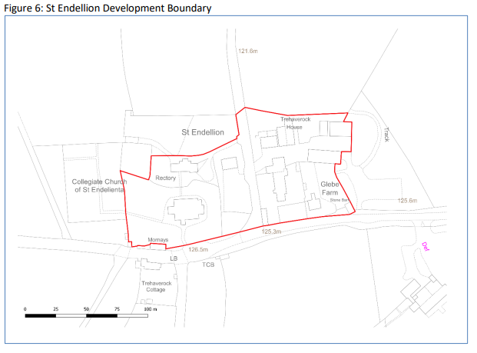

7.      There is a need to fully understand if a combined scheme (cross subsidy) best way forward as an option or alternatively that CC progresses independently with a scheme within the red line to move that ahead in advance and then the exception to follow later.  SM highlighted that CC has duty to meet best value considerations for its land when disposing and these discussions are recognised as being undertaken on a without prejudice and subject to contract and member approval basis.  CLT advised that securing Homes England funding for exception scheme likely to be easier without cross subsidy/joint scheme and exception site kept separately.

8.      Sarah/Stephen to approach planning to see if they can provide some initial advice on Highway perspective and also preferred way ahead of combined or separate scheme/what most/least favourable options are.  SR to organise.

9.      Date of next meeting Weds 18th Jan 9am – CLT/Phil to set up on Zoom.

In terms of update are you all content that I send, copying Sarah in only, the following to portfolio holder and local member.

“We met with CLT and local reps from the St Endellion affordable housing working group Weds 14th to discuss and explore next steps.  This is on without prejudice and subject to contract and member approval basis, as with all similar schemes.

CLT and local working group are to work up budget cost plan to carry out all the surveys and design work as part of the feasibility and options appraisal to take to planning application stage, this is to inform and identify funding sources to carry this out – could be between £70k-£120k.  Sarah explained the details of the emerging funding scheme CC Housing are making available in 2023 to help support communities bring forward exception sites and to develop feasibility to take to planning application phase.  Cap of £40k available per scheme but this one is on the priority list of schemes held by her team, this is on the list and in a favourable position.

Sarah and I are to discuss with planning the options on an informal basis for the site bearing in mind the policies adopted in the Neighbourhood plan for St Endellion, especially in relation to CC land ownership as there may be merit in splitting live work within development limits away from the exception site and two separate planning applications brought forward accordingly.  CLT advised that separate schemes could bring benefits when applying for Homes England funding.  No decisions made on this at this stage.

Once the cost plan has been prepared, there is likely to be a shortfall from the CC Housing funding and the CLT can assist with identifying alternative sources.  Nicola will update the Parish Council on the above at its meeting in January and seek initial views of it in terms of offering some funding towards the feasibility also.  We are due to meet again in late January.

I trust the above is a helpful update but should you have any questions or queries, please do come back to us both”.